Student Name : Raj Kumar Tiwari
Github Url : https://github.com/CrKTrT/WedDev2-Rev01
Deployed URL : https://weddev2-rev01.onrender.com

Please include screenshots of your Render config below the rubric.
Grade Band | Reading | Station | Member | Features | Code
Baseline |  | Station-store.js used |  | Showing Stations with loaded weather data  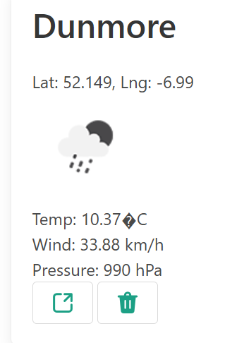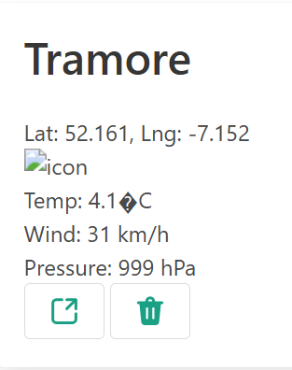 | Code submission in zip file with Readme
Release 1 |  |  |  | Dashboard shows all requirements covered as per the rubric  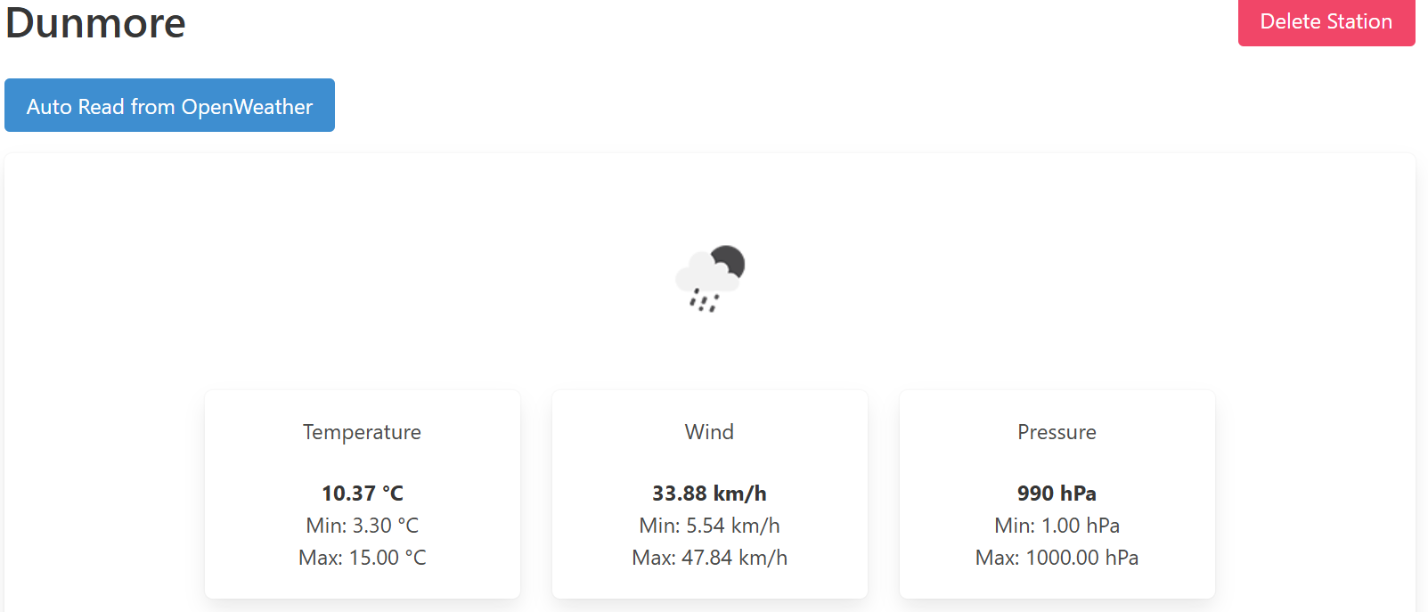 | Render Screenshot  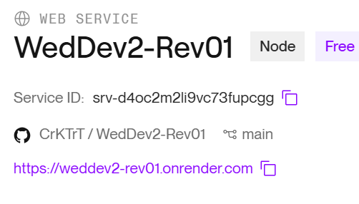
Release 2 |  | +Lat, Lng  Max/Min (Temp, Wind, Pressure | User details are visible via settings options and options to update it. Not achieved | Members can sign up via below form and also able to add stations  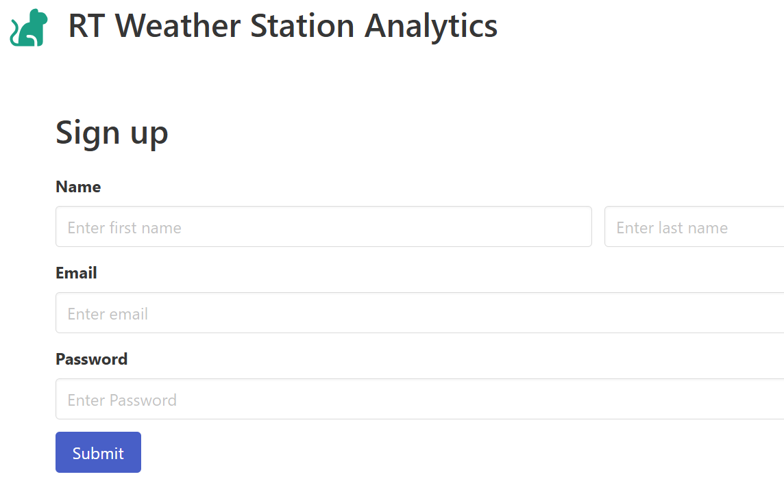  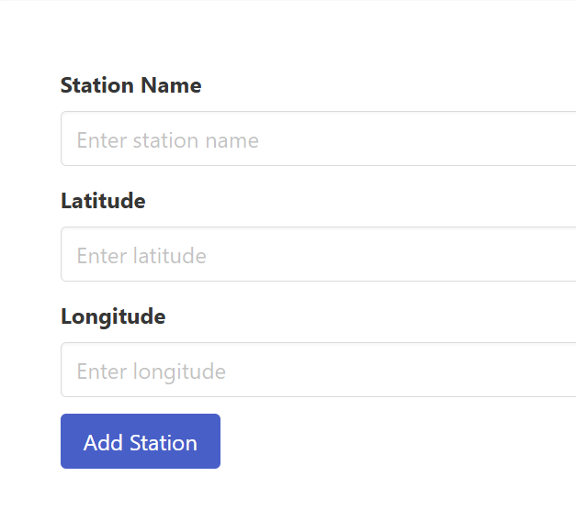 | Github Repo  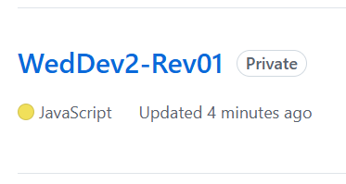
Release 3 | Time and Date is added | Trend for Temp, Wind and Pressure added  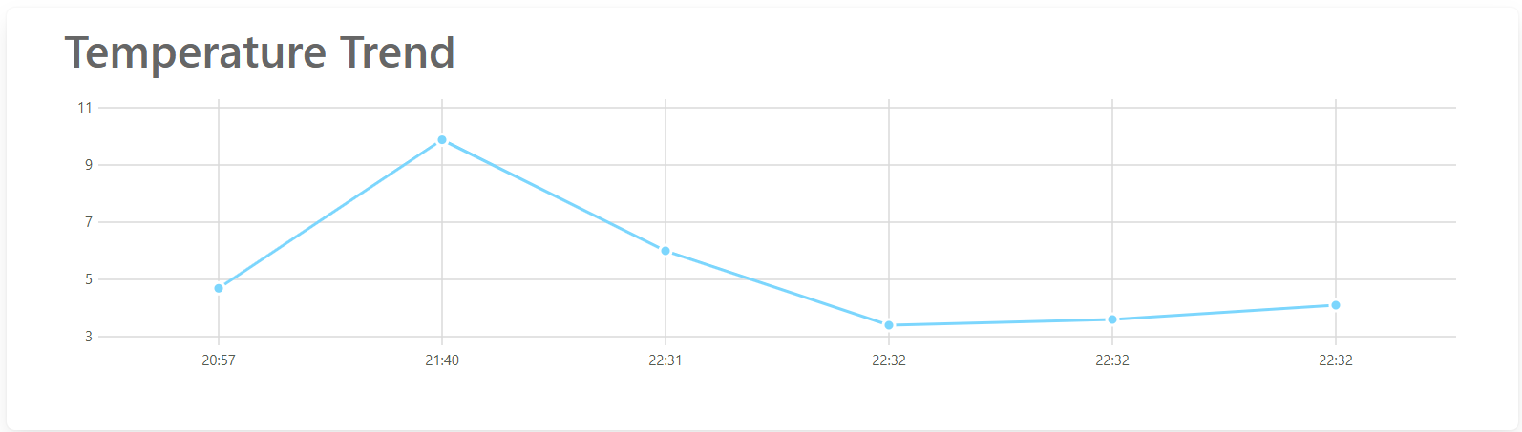  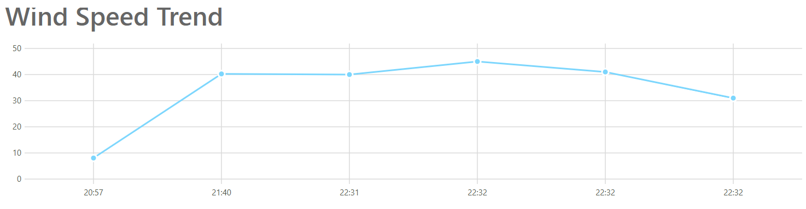  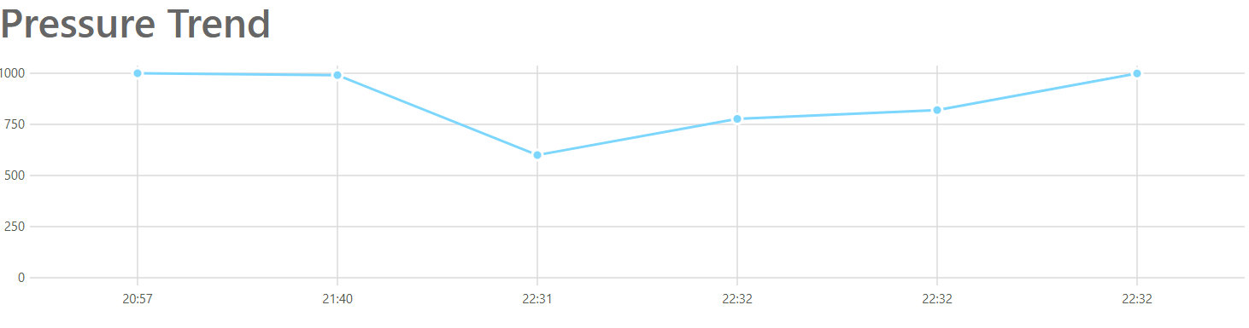 | User can update details. Not achieved | Member dashboard list summary lists latest conditions for all stations.  (alphabetically). Members can delete reports or stations
Release 4 |  | Station view map  Not achieved | Not achieved | Simple graph trend added | Tag for Github Repo  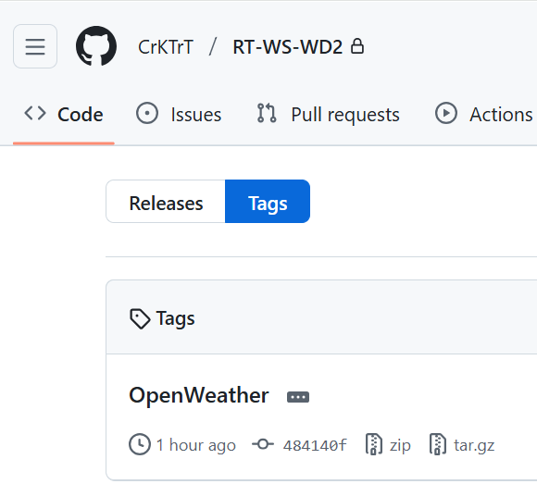

 | Reading | Station | Member | Features | Code
Baseline | Code  Temp  Wind Speed  Pressure | Station Name  Latest weather, Temp C, F, Wind Bft, pressure | None | Load and display stations + their readings from JSON file display latest weather for station | Zipped archive + Readme
Release 1 | + Wind Direction | + Wind Chill, Wind Compass | None | Dashboard shows station list + button to open station view. Include forms to add new Station + new reading | + Render Project
Release 2 |  | +Lat, Lng  Max/Min (Temp, Wind, Pressure) | First Name, Last Name, Email, Password  + Stations | Members can signup/log in. Members may create any number of weather stations. Members + sample stations + readings loaded from YAML | + github repo
Release 3 | + Time/Date | Temp, Wind Pressure Trends | User can edit their personal details. | Member dashboard list summary lists latest conditions for all stations.  (alphabetically). Members can delete reports or stations | Github repo with history
Release 4 | Auto Read from OpenWeatherMap API | Station Map View |  | Simple Graph of Trends | Github repo tags

